Web Technologies Lab-1
13-07-26

Aim:
To design or develop a personal portfolio website using HTML5 and CSS incorporating semantic HTML elements such as text formatting, hyperlinks, images, tables, lists, and modern page layout techniques such as CSS flexbox or CSS Grid
HTML FILE:
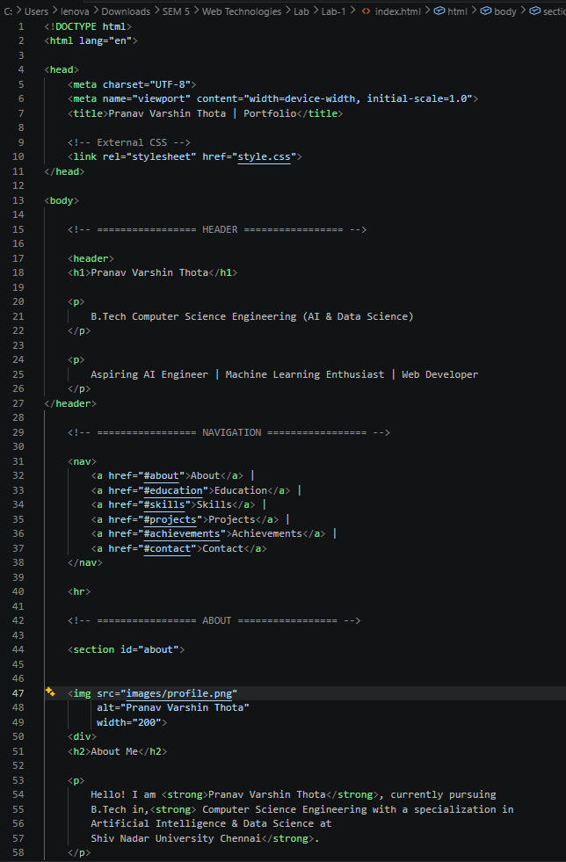
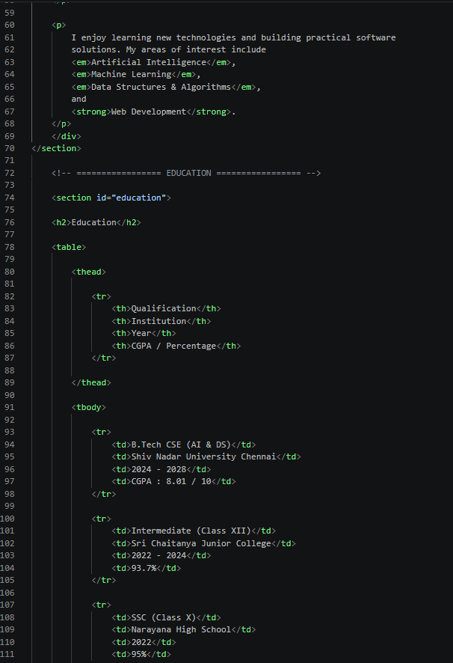

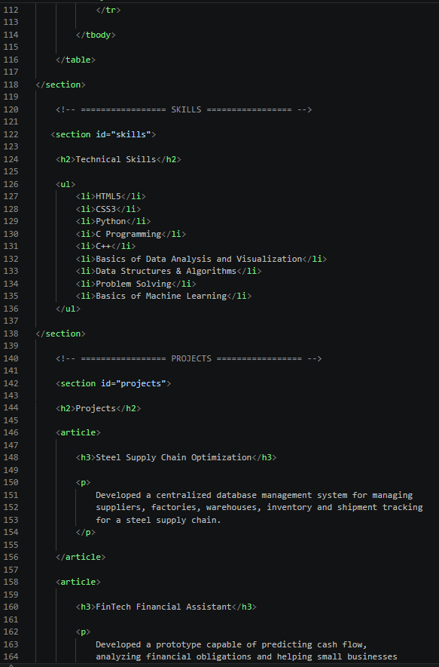

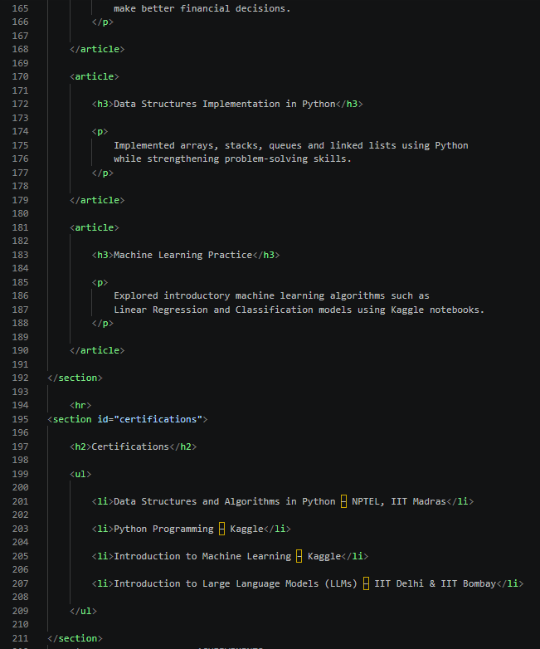

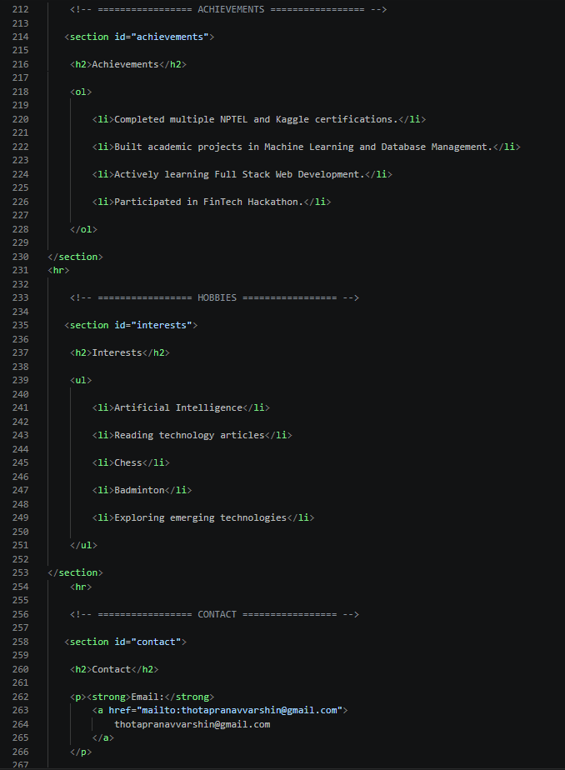

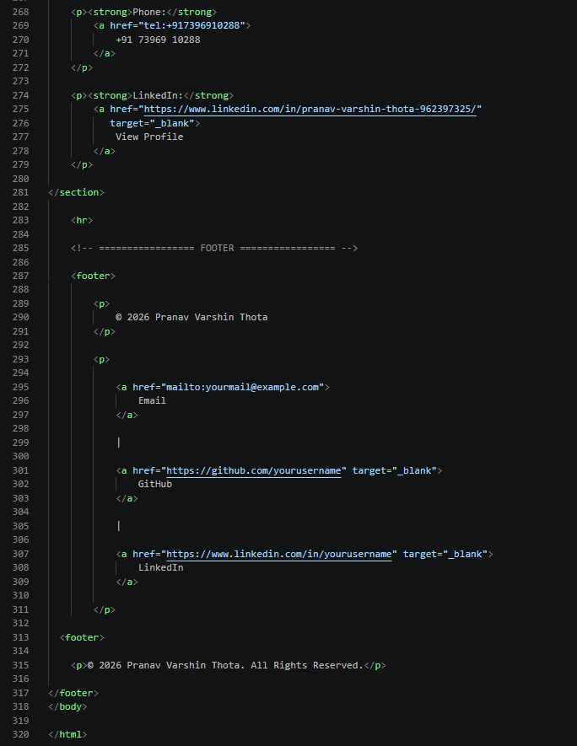

CSS FILE:
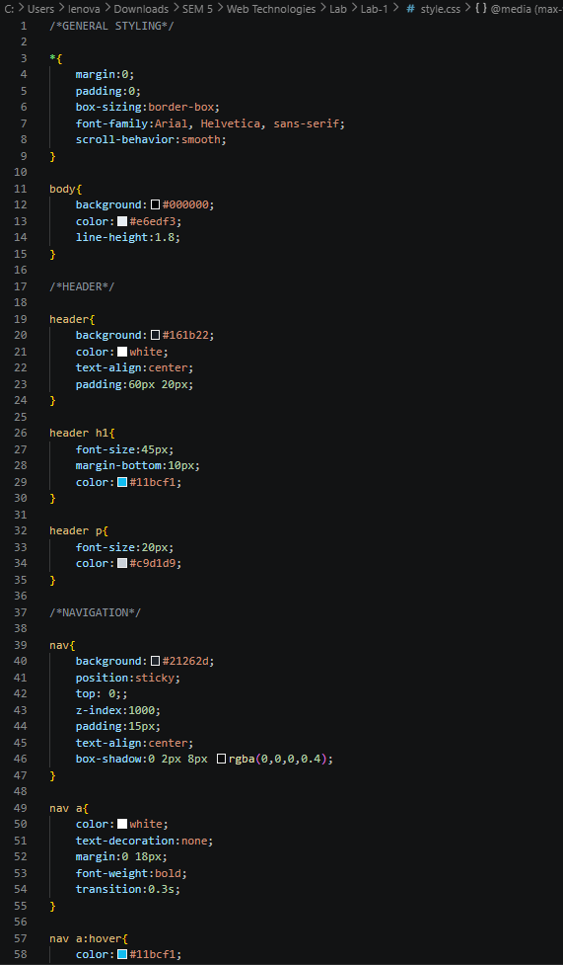
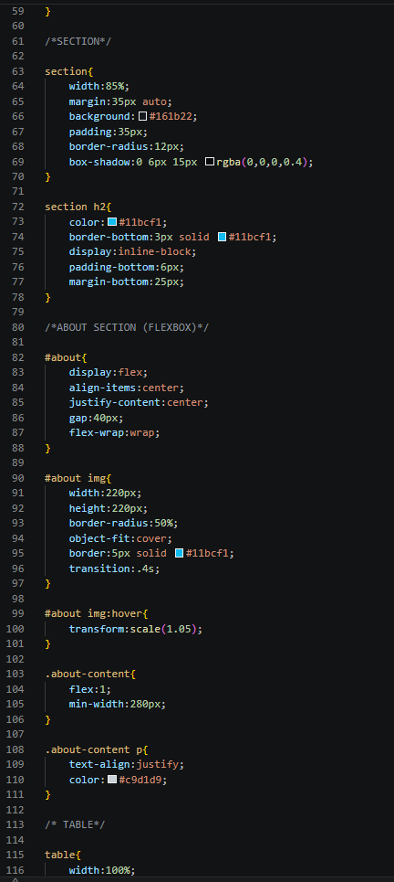
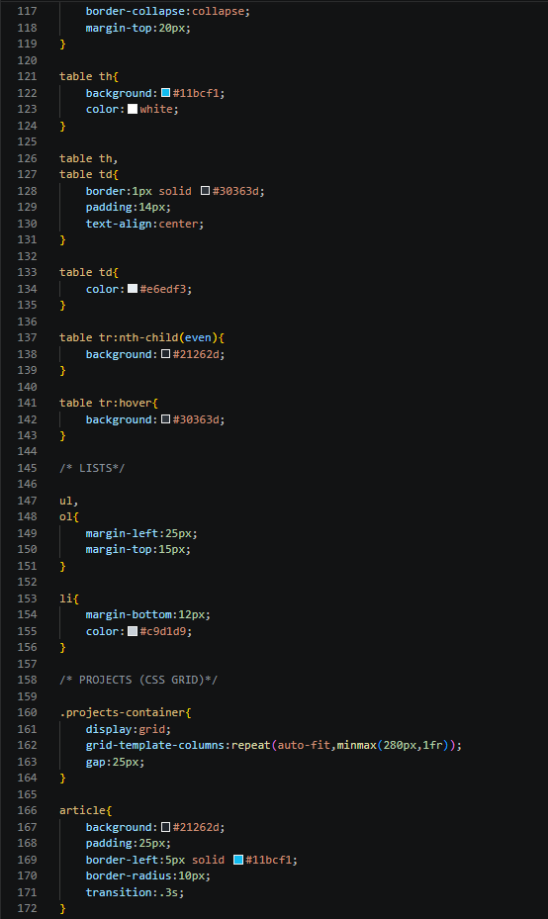
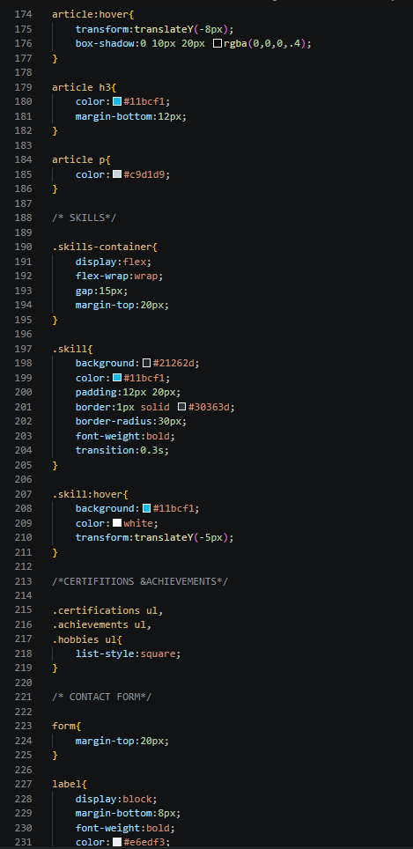
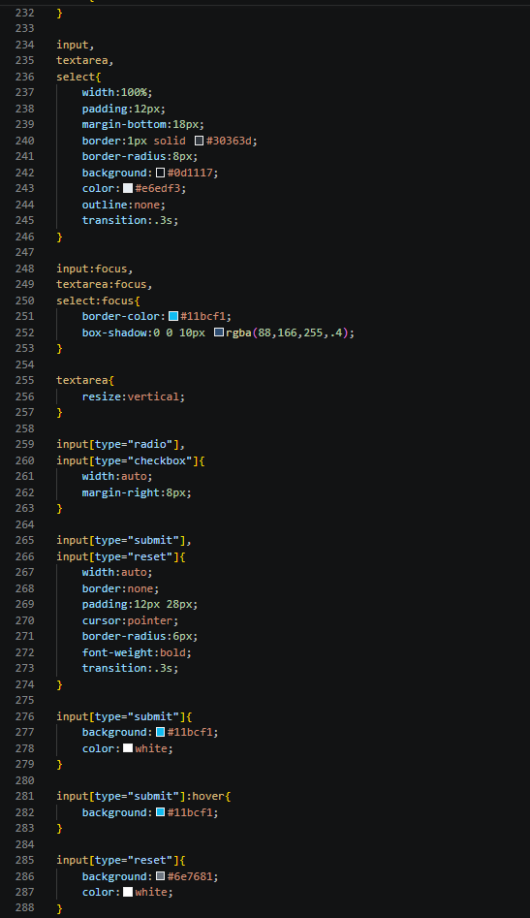
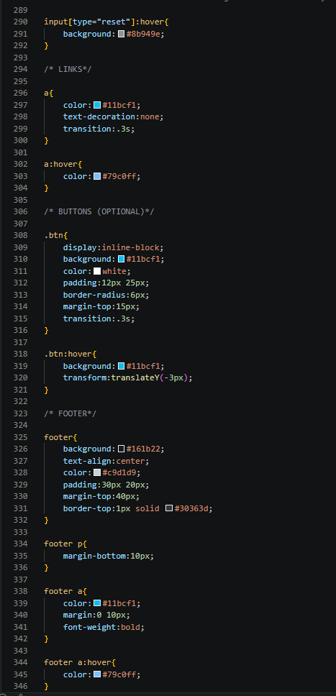
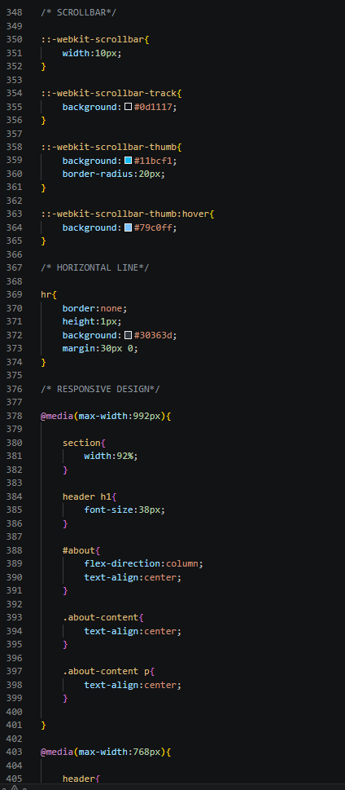
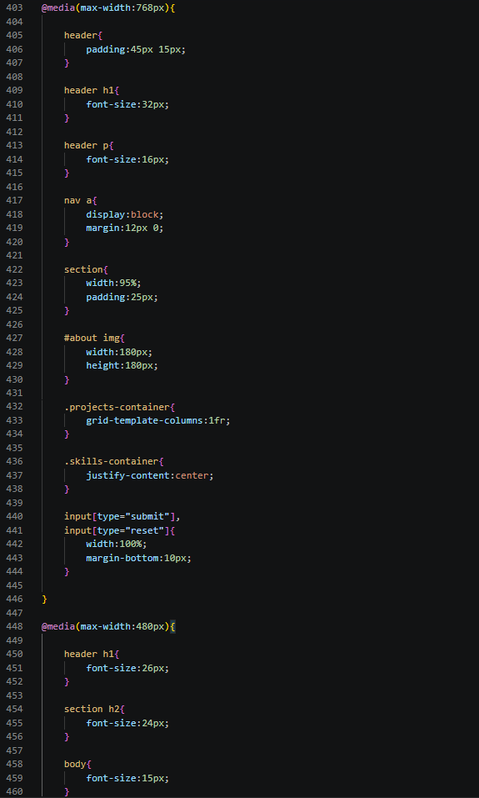
}}
Output Portfolio:
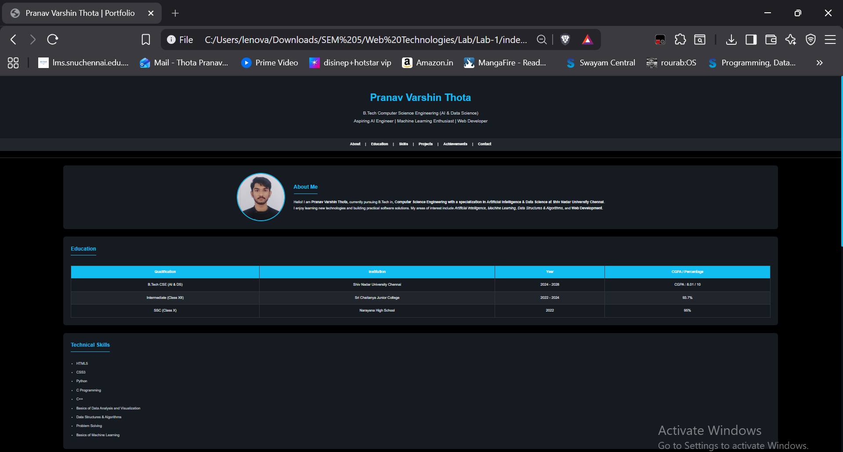
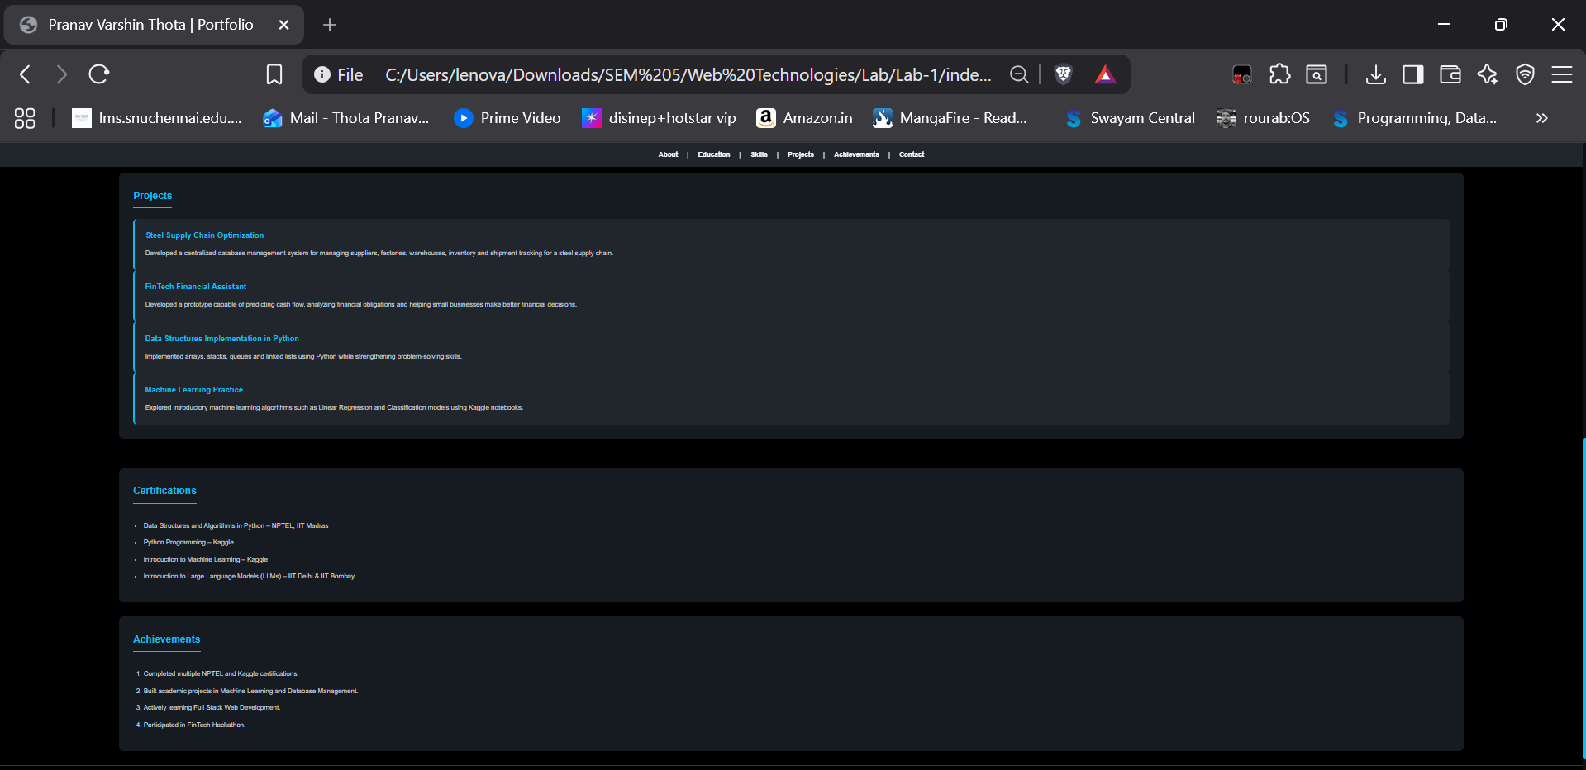
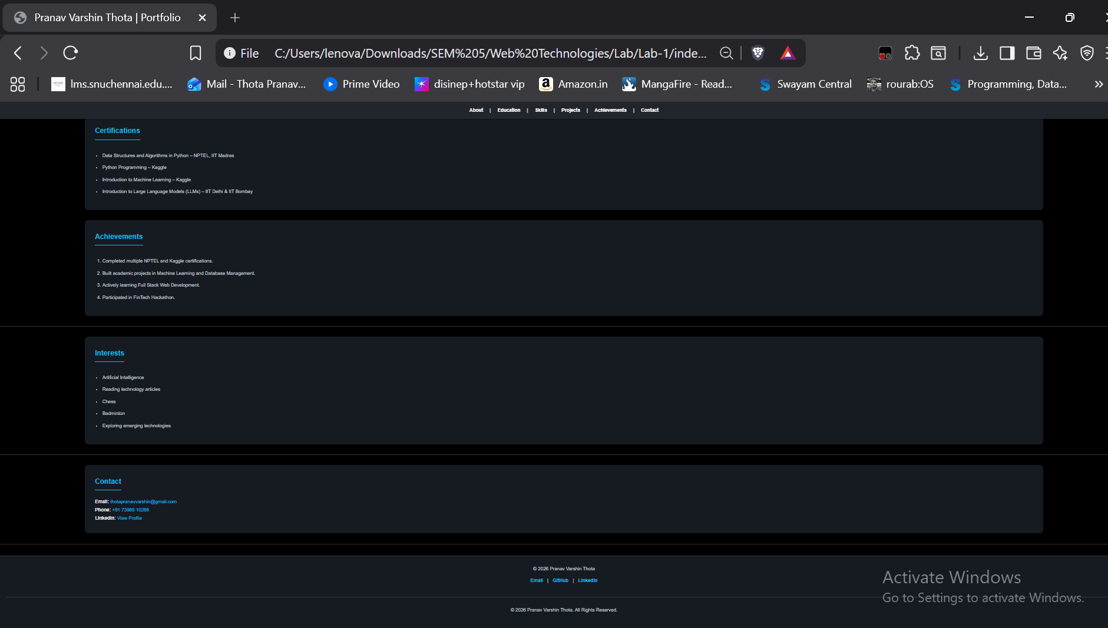
Conclusion:
The personal portfolio website was successfully designed and developed using HTML5 and CSS3. Semantic HTML elements were used to organize the content effectively, while CSS was applied to create a professional dark-themed, responsive, and visually appealing interface. Modern layout techniques such as Flexbox and CSS Grid were implemented to improve the structure and user experience. This experiment enhanced the understanding of web page design, semantic markup, styling, responsive layouts, and best practices in front-end web development.

